SALADS AND STARTERS
Side Salad…………….......6.00
(lettuce, tomatoes, Gio’s Italian dressing)
Italian Salad……….…Sm 13.00…….…Lg 17.00
(lettuce, tomatoes, Gio’s Italian dressing, artichokes, olive salad)
Caprese Salad……….Sm 13.00………...Lg 17.00
(fresh mozzarella, fresh basil, tomatoes, balsamic vinegar)
Cheesebread…………….9.00
(8 pieces per order, served with red gravy)

POBOYS – all sandwiches are toasted
Meatball (best in the city)………………… 14.00
Italian Sausage …………………………….. 14.00
Chisesi Ham & Cheese……………………..14.00
Muffaletta .........(Half) 14.00…..…(Whole) 25.00
Muffaletta Special……………………………16.00
(1/4 Muffaletta & small Italian Salad)
Chips (Assorted) ……………………………..1.00

ENTREES – served with side salad & 2 pieces of garlic bread
Spaghetti & Red Gravy…………………...14.00
Spaghetti & Garlic & Olive Oil.…...…….14.00
Spaghetti & Meatballs (2).……………….19.00
Spaghetti & Italian Sausage ……………..19.00
Spaghetti Combo (Meatball/Sausage)…19.00
Chicken Parmesan………………………..19.00
Eggplant Parmesan……………………….19.00
Veal Parmesan……………………………. 22.00
Lasagna …………………………………….21.00

SIDES
Side Meatball……………………………….4.00
Side Italian Sausage……………………….4.00
Side Red Gravy …………………………….2.00
Extra Garlic Bread (2)…….………………1.00

DESSERTS
Cannoli …………..…4.00
Leman IceBox Pie….5.00
Fig Cookies ………..8.00 (when available)

DRINKS
Tea 3.00 Quart of
Bottled Water 3.00 Gio’s Red Gravy
Soft Drinks 3.00 $15.00
Domestic Beer 6.00
Imported Beer 6.00
PIZZAS
14” (cut into 8 slices)

Cheese (mozzarella, sauce)……………………………………………………………….18.00

Pepperoni (pepperoni, mozzarella)…………………………………………………….20.00

Bacon Cheeseburger (meatball, cheddar cheese, bacon) ……………………..25.00

Capri (ham, mushrooms, artichokes, black olives)…………………………………… 25.00

Combo(pepperoni, mozzarella, Italian sausage, green peppers, onions, mushrooms, black olives)………………………………………………………………………………...…. 26.00

Gio’s Special (pepperoni, ham, onions, black olives, mushrooms) ……………..25.00

Greek (pesto sauce, spinach, black olives, feta, tomatoes)…………………………. 25.00

Hawaiian (ham, bacon, pineapple)…………………………………………………….. 25.00

Italiano(Italian sausage, green peppers, banana peppers, onions) ……………… .25.00

Margherita (tomatoes, mozzarella, sweet basil)…………………………………......21.00

Meat (pepperoni, Italian Sausage, meatball, ham, bacon) …………………………. 26.00

Muffaletta (ham, salami, homemade olive salad) ………………………………….. 25.00

Pesto (pesto sauce, spinach, artichoke hearts, feta) ………………………………… 25.00

Quattro Formaggi (mozzarella, cheddar, provolone, feta) …………………… 25.00

Veggie (green peppers, onions, mushrooms, black olives)…………………………21.00

1.00 2.00 5.00
garlic pepperoni chicken
jalapeno ham eggplant
black olives meatball
bell peppers bacon
mushrooms Italian sausage
onions feta
pineapple cheddar
spinach mozzarella
tomatoes olive salad
banana peppers salami
basil artichoke hearts

***ALL PRICES INCLUDE TAX / PRICES SUBJECT TO CHANGE***

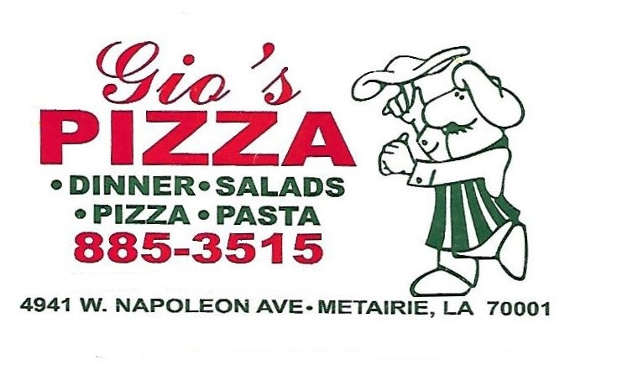

www.giospizza1984.com

Tuesday 11:00am – 2:00pm
4:00pm – 7:30pm

Wednesday 11:00am – 2:00pm
Closed for dinner

Thursday 11:00am – 2:00pm
4:00pm – 8:00pm

Friday 11:00am – 2:00pm
4:00pm – 8:00pm

Saturday 4:00pm – 8:00pm

DINE-IN OR CARRY-OUT
ALL MAJOR CREDIT CARDS ACCEPTED

Catering Available – Call for more info

